MF-LOGP Algorithm Instruction List
The instructions provided in this document will give step-by-step instructions on how to run the MF-LOGP algorithm that was published in “Dimensionally Reduced Machine Learning Model for Predicting Single Component Octanol-Water Partition Coefficients”.
The instructions are designed for Windows operating systems. It is encouraged that users read through all steps, regardless of coding experience, to avoid confusion in later steps.
Some steps will have bolded text at the end of the statement. These texts are either directional instructions for the computer or code that can be directly copied into the terminal.
For questions about running this program, please contact the principal investigator:
Dr. Andrew R. Teixeira
arteixeira@wpi.edu

Download Python
- Download and install the newest version of Python (here). Take note of the install file directory.
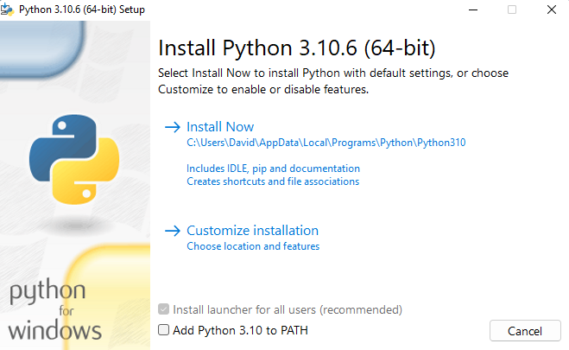
- Open the install directory and confirm that an executable instance of python is located within the folder
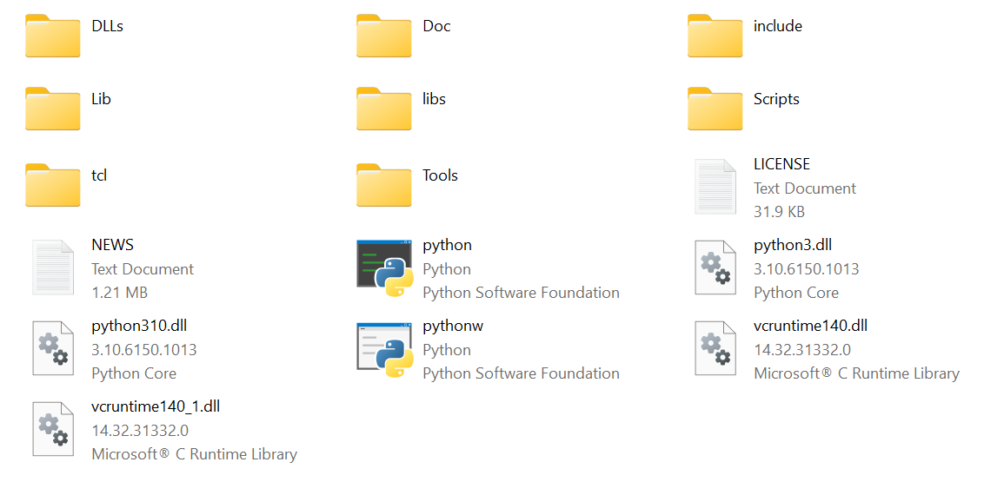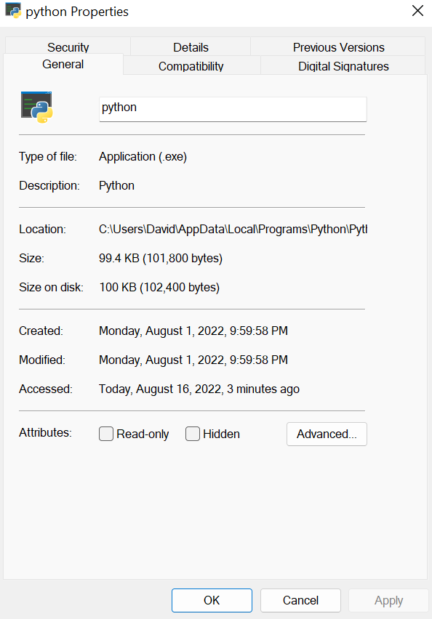
- Open a Windows Command Prompt: Start (Windows) > “Command Prompt”
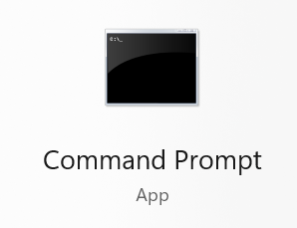

- Once the prompt is opened, in the command, confirm that you are operating in the newest version of Python by running py --version
  - As of Aug, 2022 Python 3.10.6
- The pip install tool will be a critical aspect to running the codes. Please confirm that the pip install tool was downloaded with the Python application by running py -m pip help
  - The help menu should appear if present. If the help menu does not appear, or an error message is presented, re-install Python and ensure that pip is included in the downloaded packages.
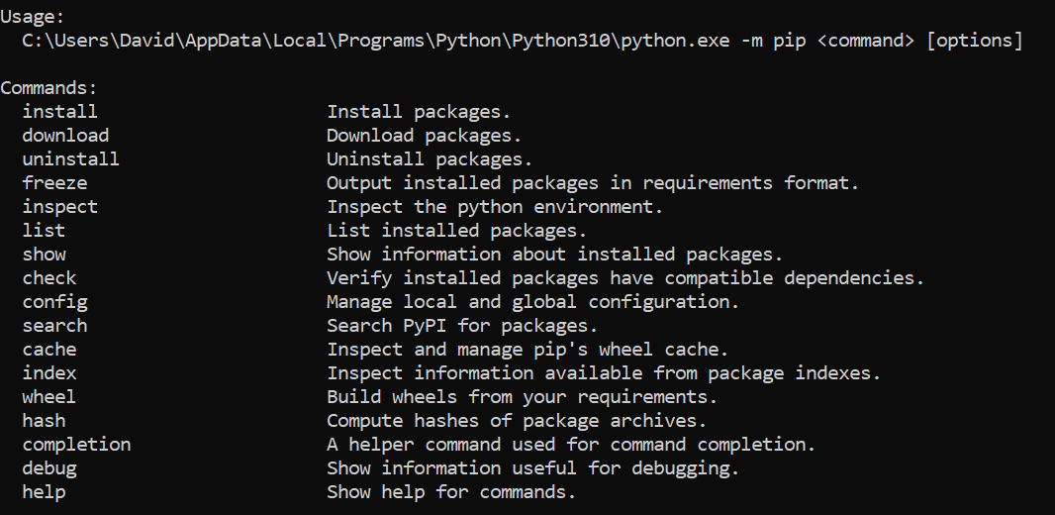

Downloading MFLOGP Files from GitHub
- Go to the Teixeira Research Lab GitHub and enter the MF-LOGP_Development- branch (here)
- Download a copy of the repository in a zip file format: Code > Download ZIP
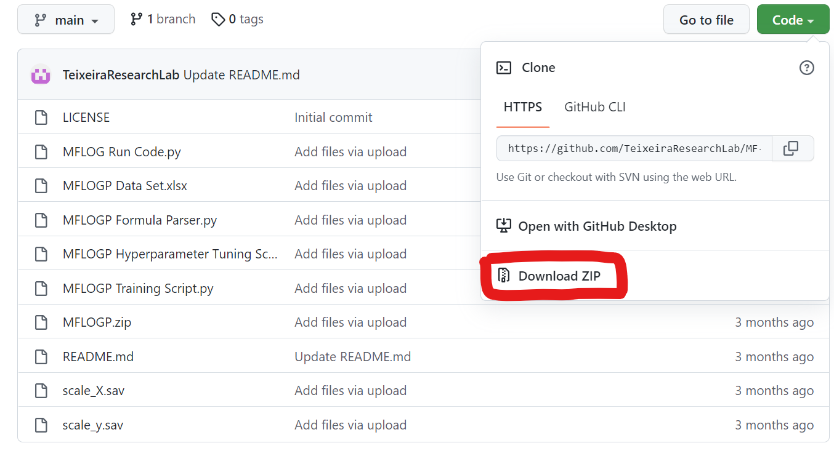
- The file will download as MF-LOGP_Development—main. Unzip and extract the file to the same Python directory noted in Step 1. Please note the directory of this file as well.
- Open the file and ensure you have the following files:
  - MFLOGP.sav
  - MFLOGP_Run_Code.py
  - scale_X.sav
  - scale_y.sav

NOTE: Additional files will be downloaded but the four listed above are the core files needed to predict partition coefficients

Download All Relevant Python Packages
If you have just downloaded Python and are running code via the command prompt, you will need to download function packages to properly use this code. If you have these packages installed already you can skip this portion. If you are unsure if the packages are downloaded, you can run the commands below and it will inform you if the packages are already present.
- pip update: py -m pip install --upgrade pip
- NumPy (Documentation): py -m pip install numpy
- Pandas (Documentation): py -m pip install pandas
- Sklearn (Documentation): py -m pip install sklearn
- MatPlotLib (Documentation): py -m pip install matplotlib
- Chemparse (Documentation): py -m pip install chemparse
- Joblib (Documentation): py -m pip install joblib
Editing Python Scripts
- Using the File Explorer, enter the MF-LOGP_Development--main folder that was placed in the Python directory. Right-click on the MFLOGP_Run_Code.py to open the script in a notepad

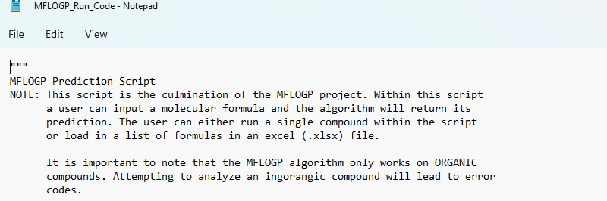

- Scroll down to the User Inputs section:
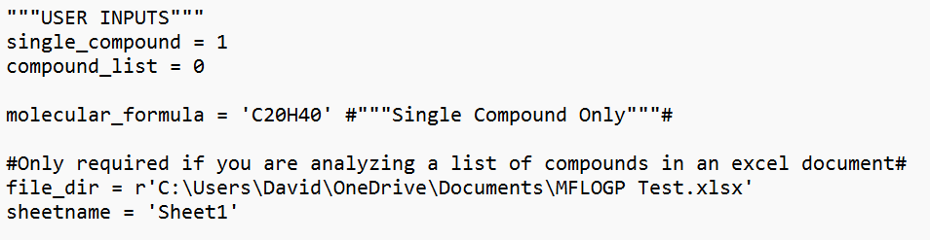
  - First, choose if you would like to analyze single compound or multiple compounds via an excel spreadsheet. The 1 and 0 are logical statements (1 = Yes, 0 = No)
  - If looking at a single compound (single_compound = 1), simply change the molecular formula to the compound of interest.
NOTE: This algorithm can only accept compounds with (C, H, N, O, S, P, F, Cl, Br, I) without further training.
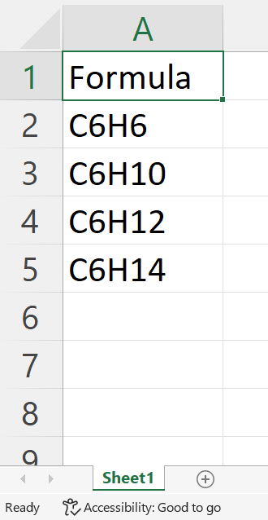
  - If looking at multiple compounds (compound_list = 1), add the file directory for the excel document containing the list of compound formulas under file_dir
    - If running multiple compounds, ensure that the compound list is in Excel, the sheet name matches the Excel document, and the list has a header ‘Formula’
  - Save and close the excel document

- Save the document. The notepad can be closed or remain open.
- Change the command prompt directory to that of the unique file path from Step 8: cd Enter File Path
  - Once entered, you will see a change in the text prior to the cursor location
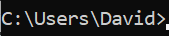
- Run the MF-LOGP algorithm: py -m MFLOGP_Run_Code
  - The output might be led by warnings messages, but the final partition coefficient prediction(s) will be the final output in double brackets
Single compound: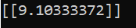
Multiple compounds: 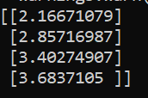

End of Instructions

